Introduction

**“Trakt list Subscription”** is an addon that expands the [Pulsar](http://forum.kodi.tv/showthread.php?tid=200957) experience, providing user the ability to play content via local library integration. In that way, users that manage a watch list in TRAKT can benefit from **Trakt list Subscription** addonas it downloads the whole list by creating locally small .strm files that Kodi recognizes as local files. The advantage is that user has all the tools from local library such as trailer, cinema experience, etc.

KODI's preparation

The script needs two folders in order to save the MOVIES and TV SHOWS .strm files accordingly. Besides that, it is necessary to configure those folders as Video Sources for Kodi's scrapers to be able to get all the meta-information of the .strm files (posters, name, actors, etc).

*If you need further assistance for setting folders as video sources look here:* [*Adding Video Sources*](http://kodi.wiki/view/Adding_video_sources)*.*

Setting up Trakt list Subscription

Before using the script, we have to install and configure it.

We can find it in three different repositories (Pulsar Unofficial, Pulsar Unofficial mirror and Kodi Underground) following the steps pictured bellow:

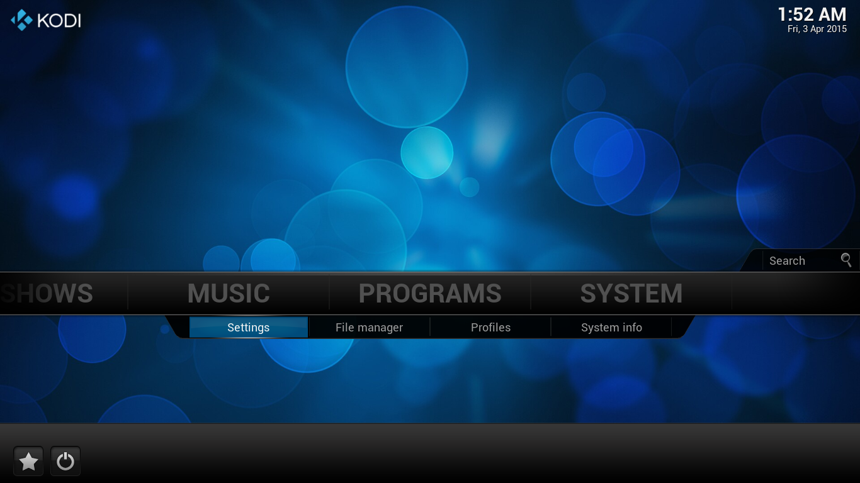

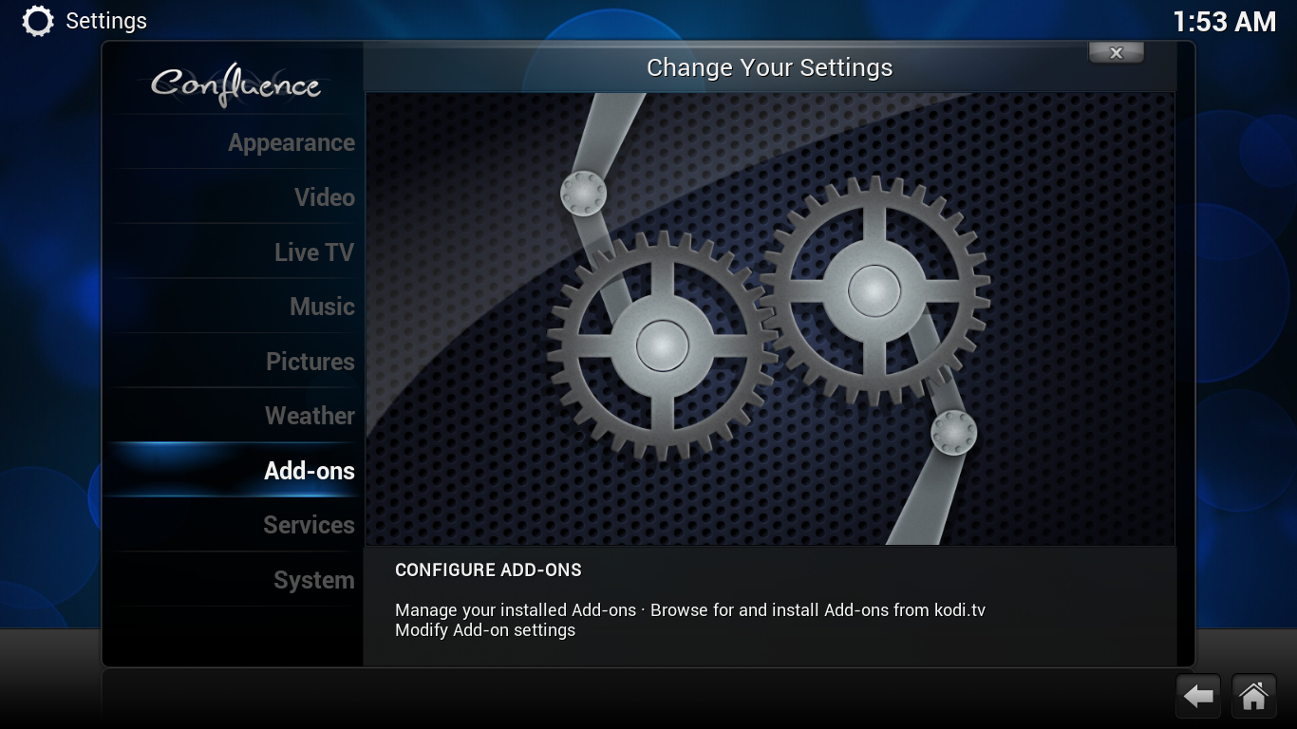

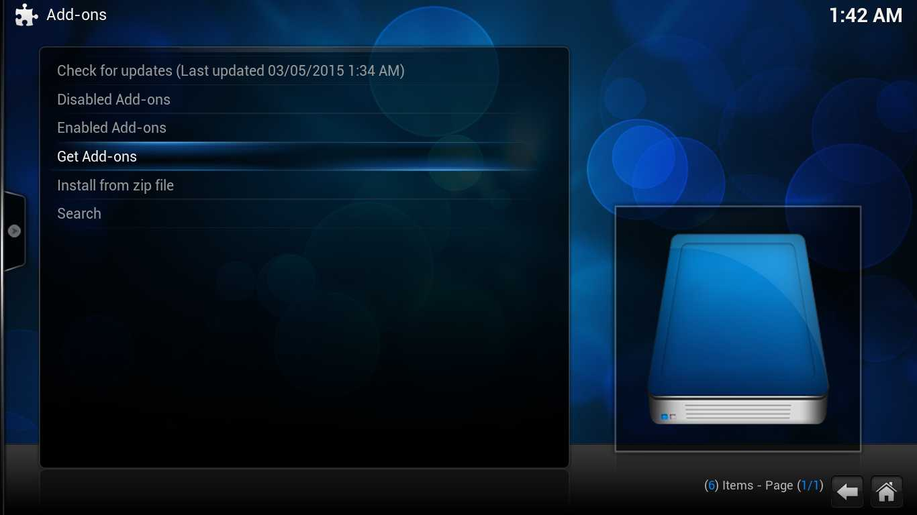

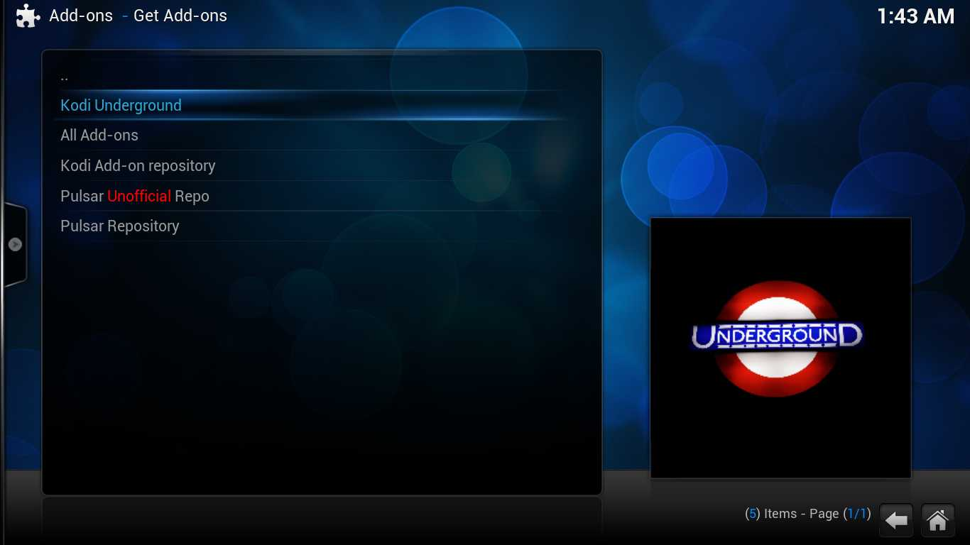

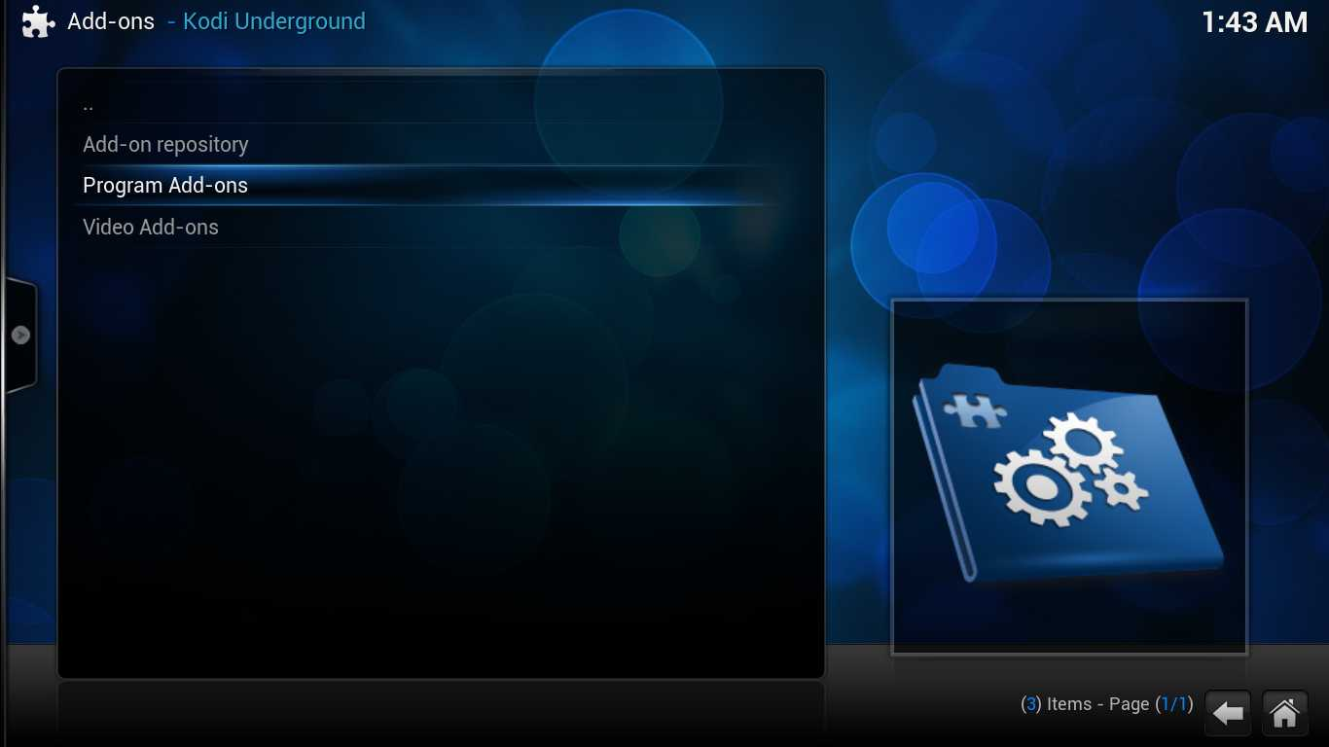

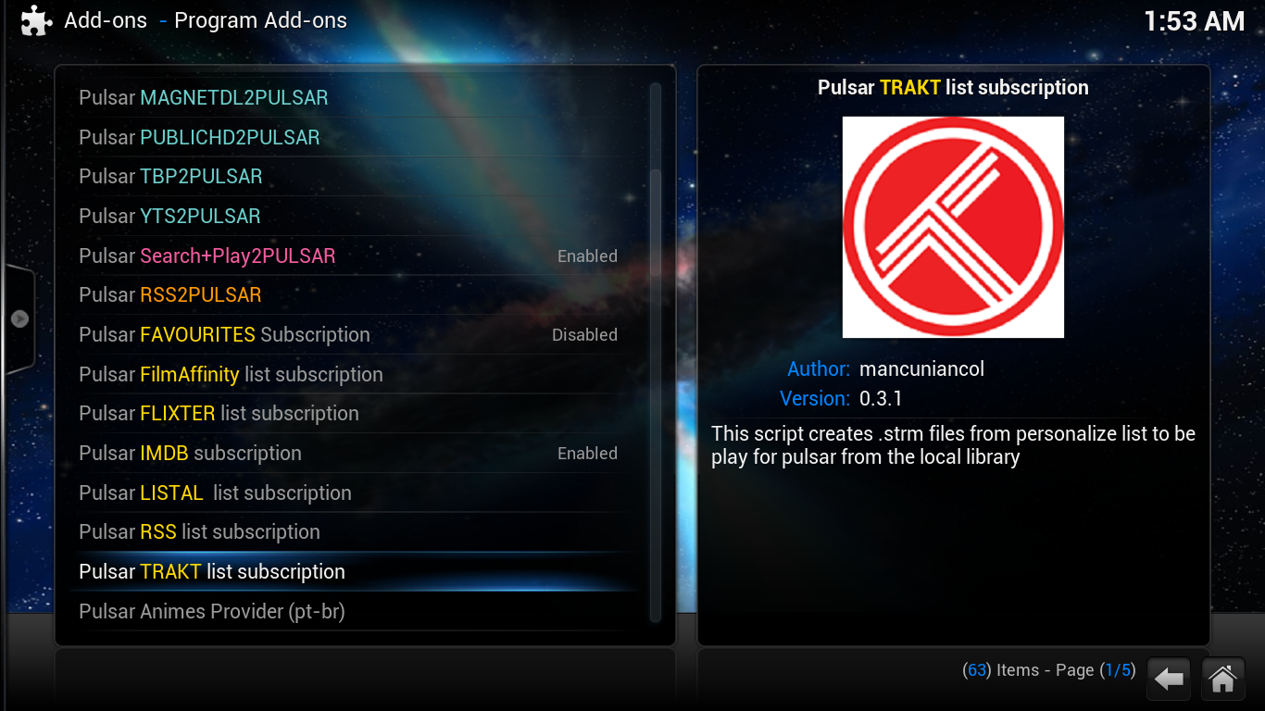

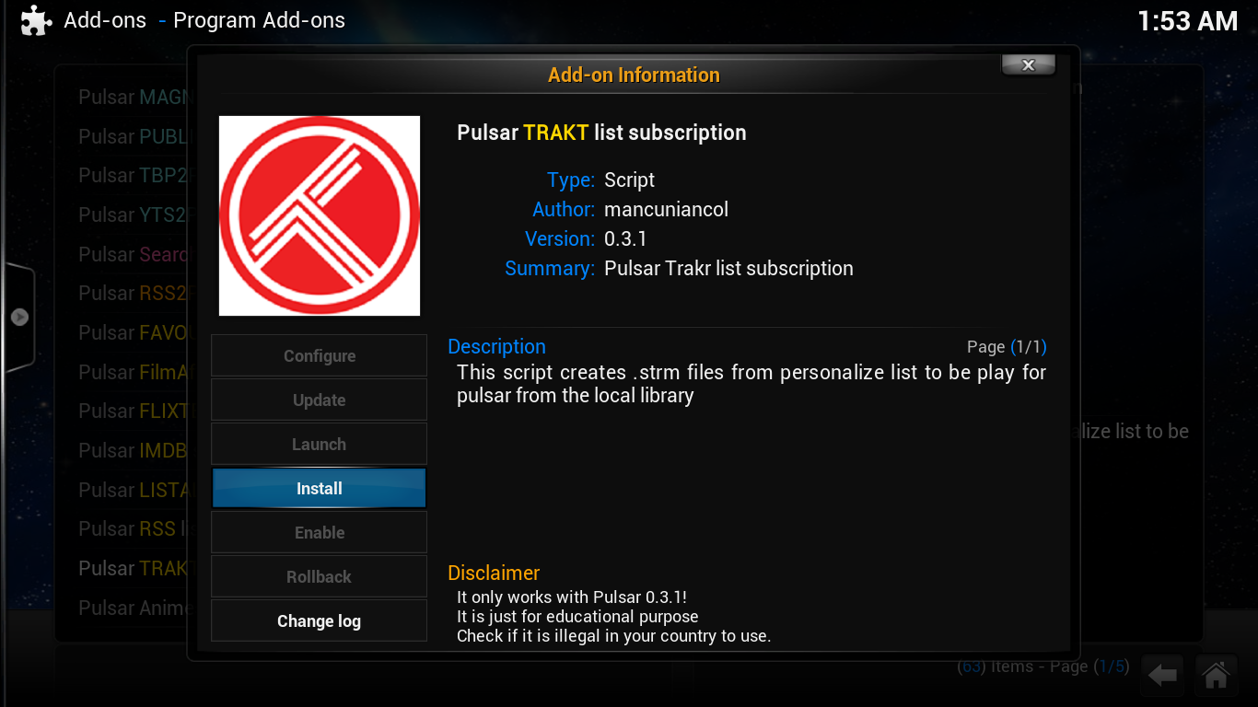

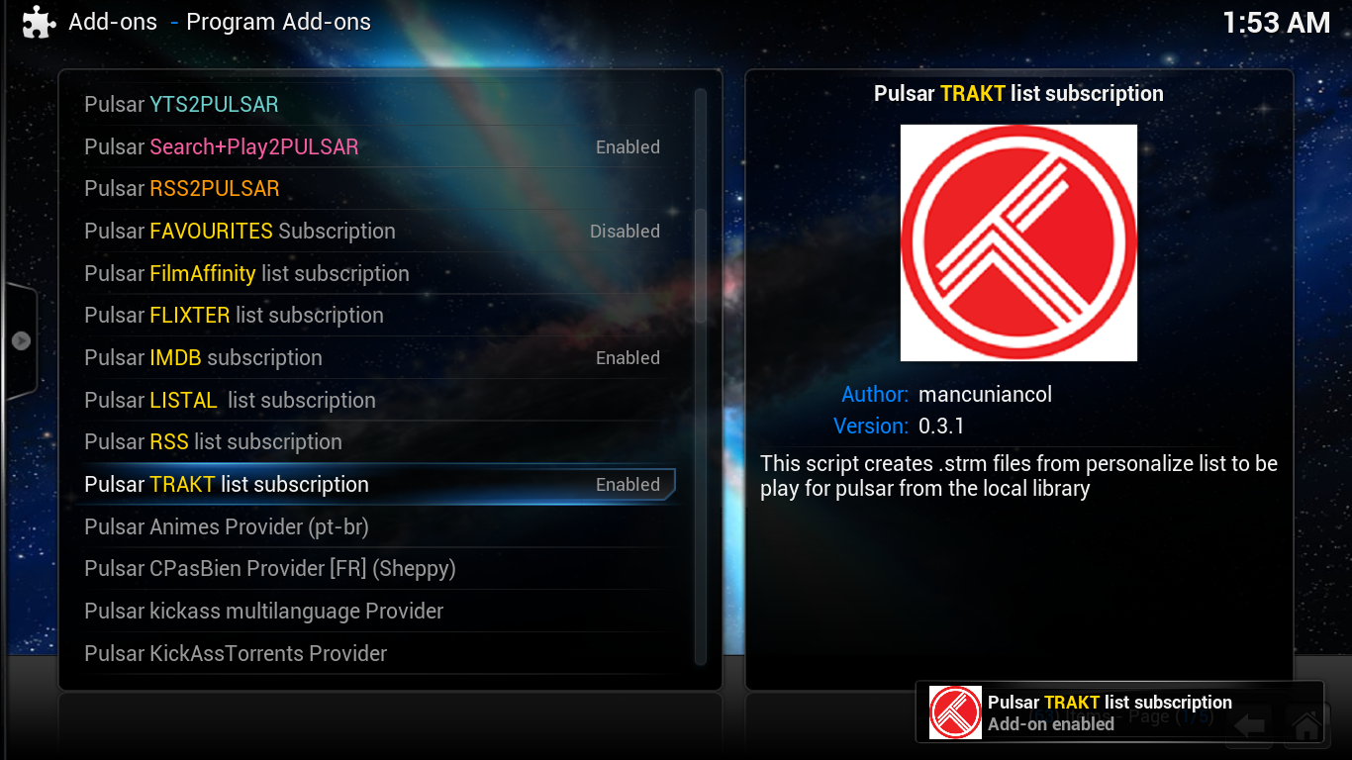

Configuring Trakt list Subscription

After we enable the script, we have to configure it

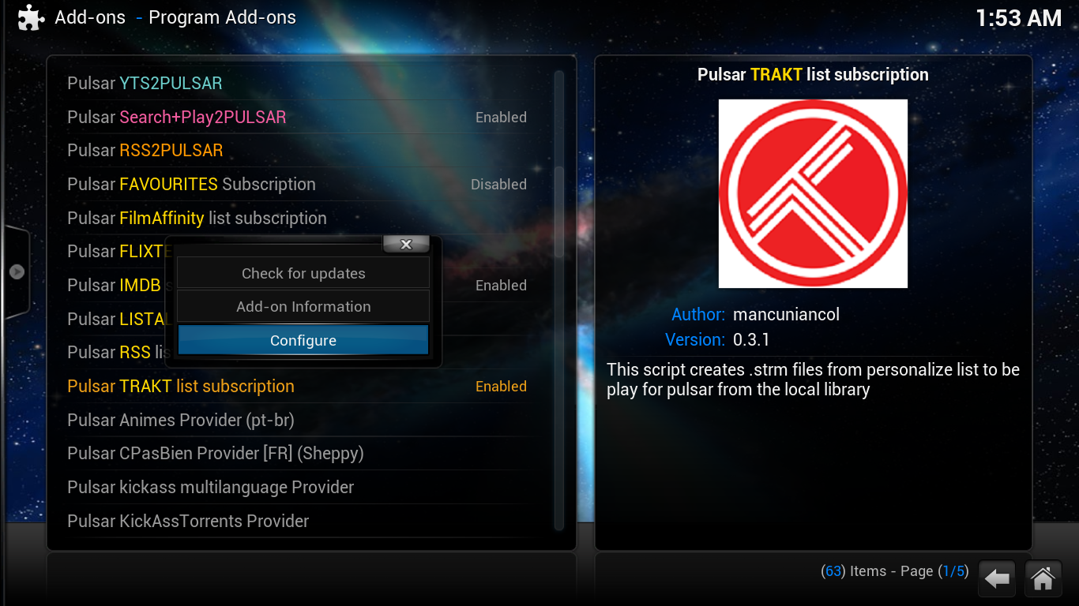

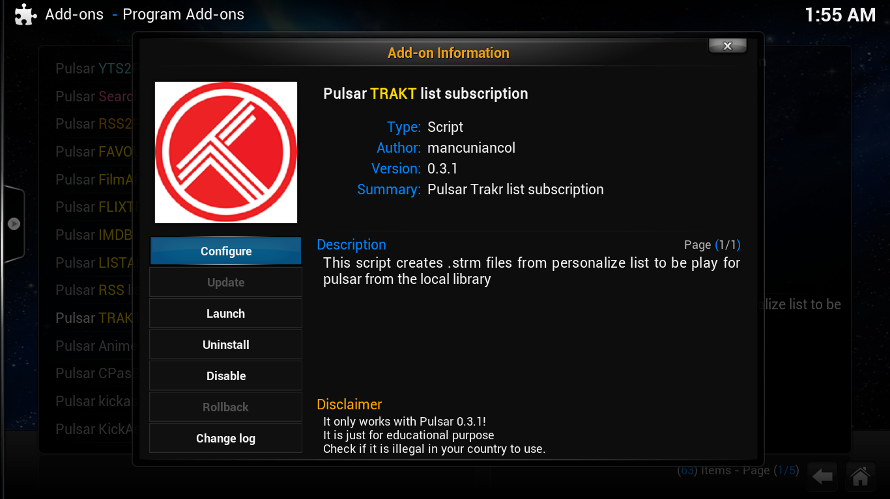

In the General Tab:

* We set the desired Movie and TV Show folders in order to save the .strm files,
* The Action…
* The “Clear Database” radio button clears the sql database that the script uses and the “Remove All .strm Files” physically deletes all the .strm files from the Movie and Show Folders.
* The “Type of Library”…

In the Service Tab:

* “Run as Service”: We check the radio button in order to make the script check for updates in every login,
* “Persistent Update @8h”: We check the radio button if we want the script to check for any updates in every 8 hours,
* “Start delay (in seconds)”: The seconds that will pass (after Kodi’s start up) for the script’s initialization
* “Sync Movies Popular”: We check the radio button in order to …
* “Sync Movies Trending”: We check the radio button in order to…
* “Sync TV Popular”: We check the radio button in order to “Sync TV Trending”: We check the radio button in order to…
* “Sync Watchlist”: We check the radio button in order to synchronize with a specific TRAKT account

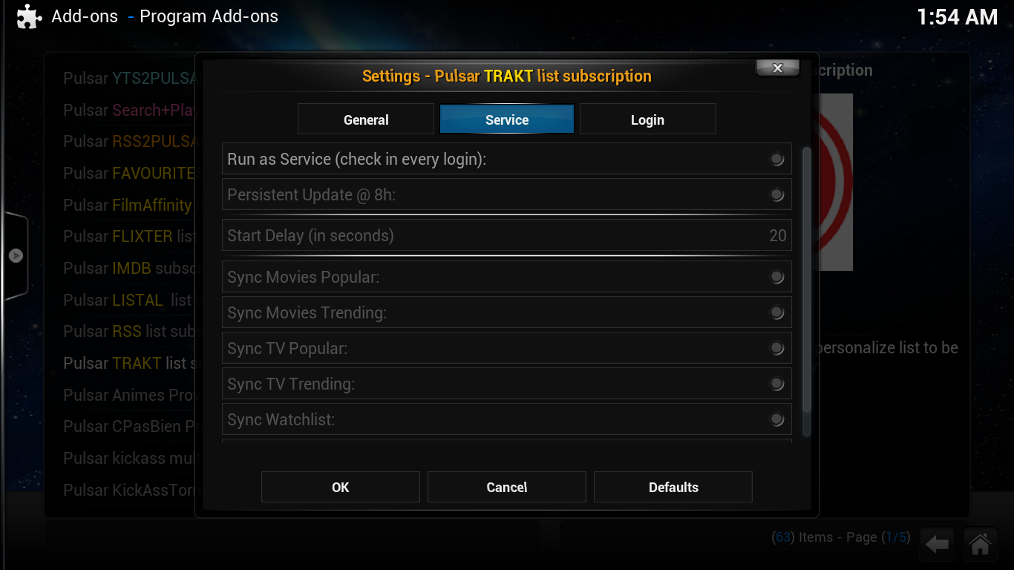

In the Login Tab:

* User has to fill in the appropriate Username & password that uses with TRAKT.tv

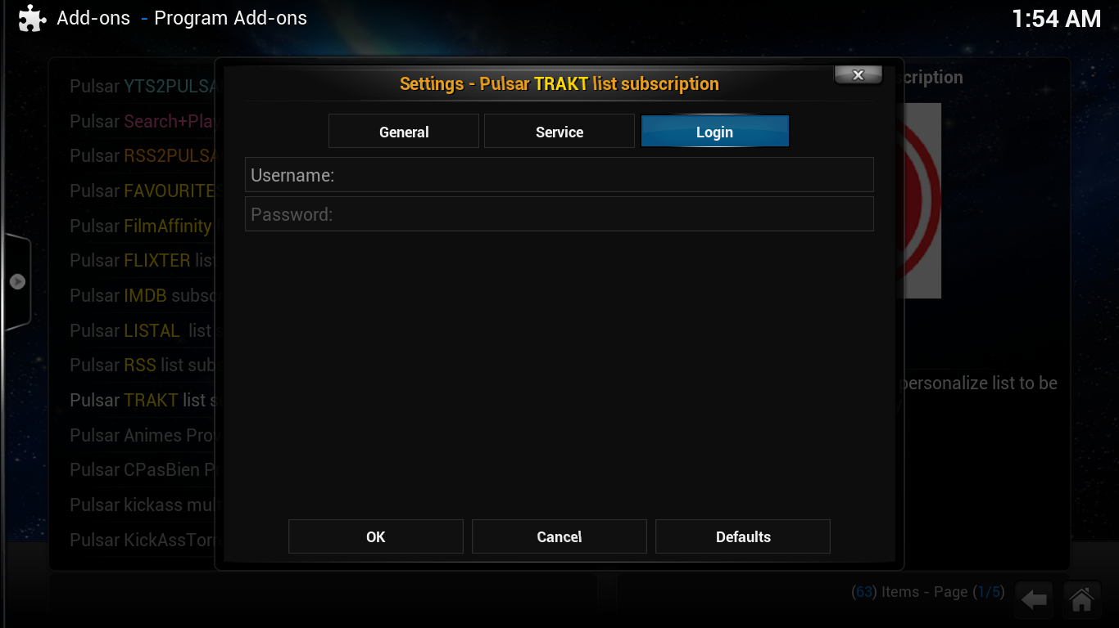

After pushing the OK button, a pop up screen opens in order to choose the list that you want to synchronize.

And again the confirmation of the TRAKT’s user code (it is already filled in the service tab)

In a few seconds, the subscription list is active and a confirmation dialogue pops up.